Random Controller And Random Order Controller

Right Click on test plan—select Thread Group---Give Results Tree---Right click on thread group—Controllers—random Controllers.

This Executes the test script randomly.

Example:

If we have ,

PreCondition—test1—post condition.

PreCondition—test2—post condition.

PreCondition—test3—post condition.

From above example it executes any 1 test , it can be like Pre—test1—post (or) pre—test2—post (or) pre—test3—post .

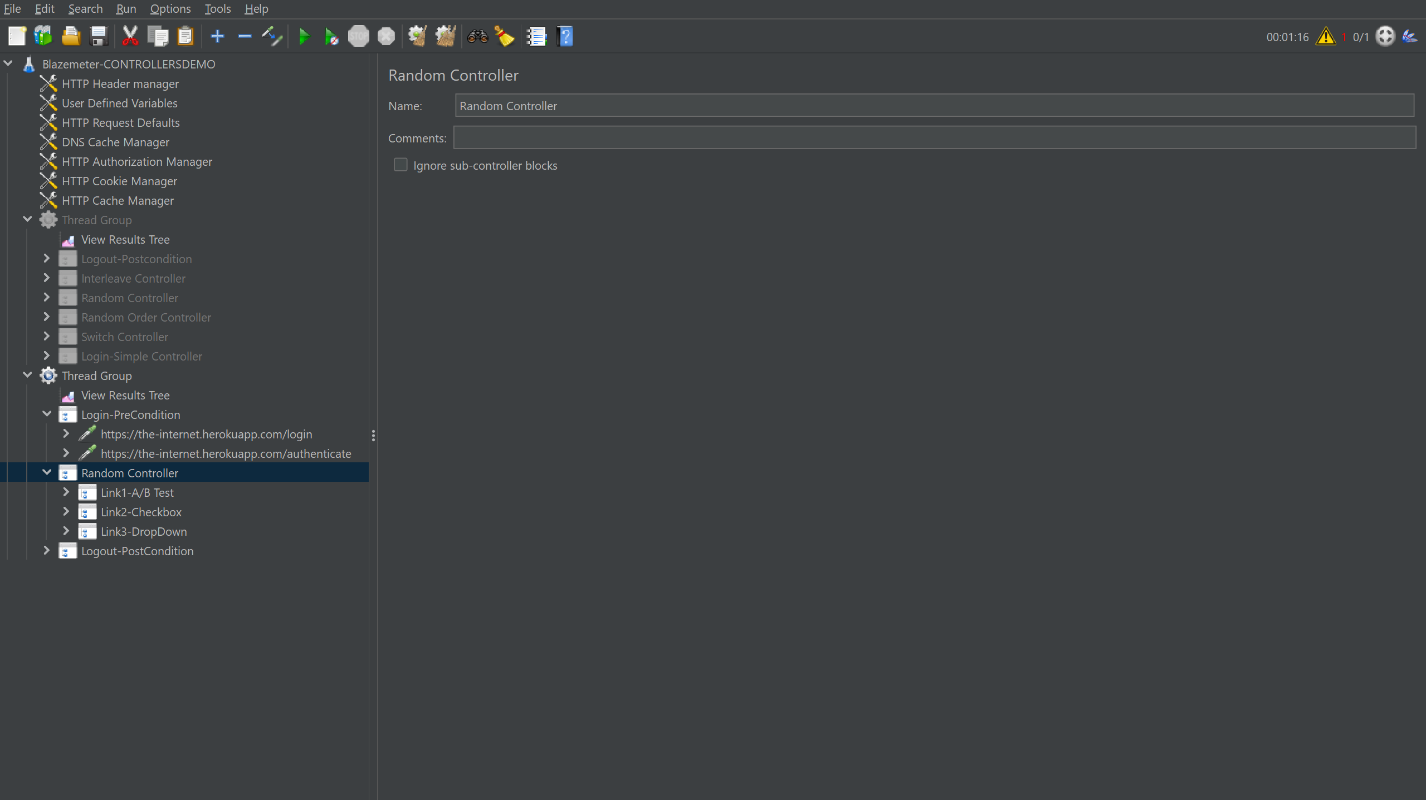

As seen below..i given 3 Scripts ..

1.Login

2.Random controller—link1,link2,link3

3.Logout.

From below we got execution only one test script randomly.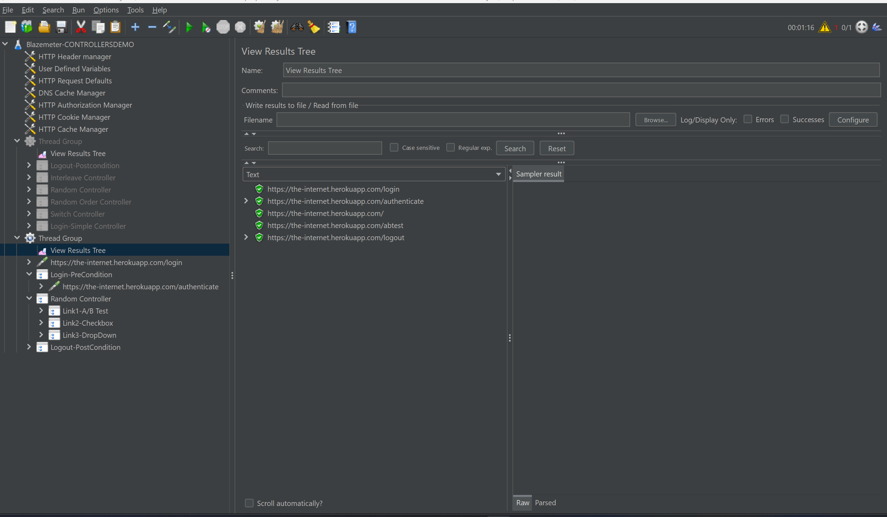

Random Order Controller:

A slight difference from above random controller, above controller executes only one test script like link1 or link2 or link3 randomly.

But this ROC executes all scripts at a time below pre condition and above post condition randomly.

Example:

If we have ,

PreCondition—test1—post condition.

PreCondition—test2—post condition.

PreCondition—test3—post condition.

Output like:

Pre—test1 or test 2 or test3--post

